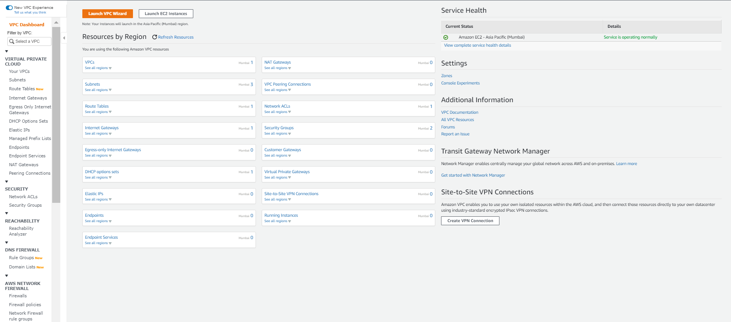

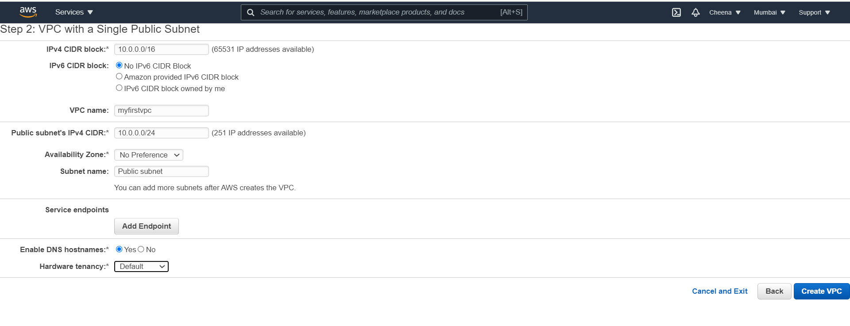

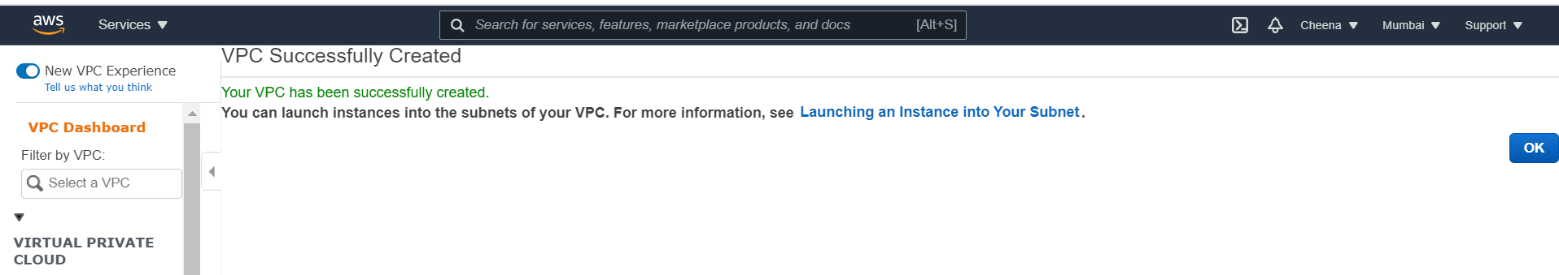

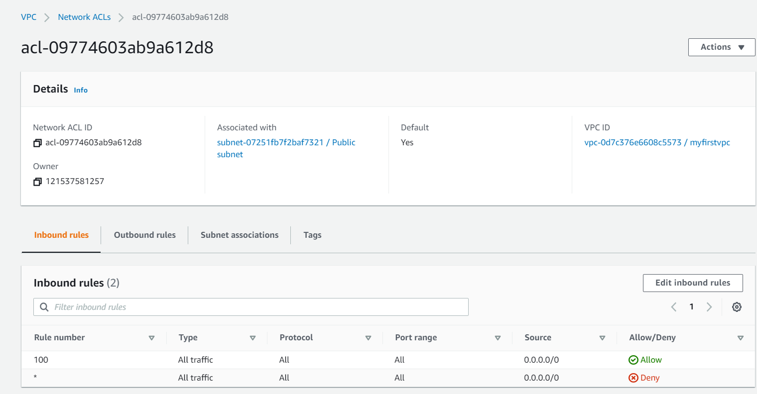

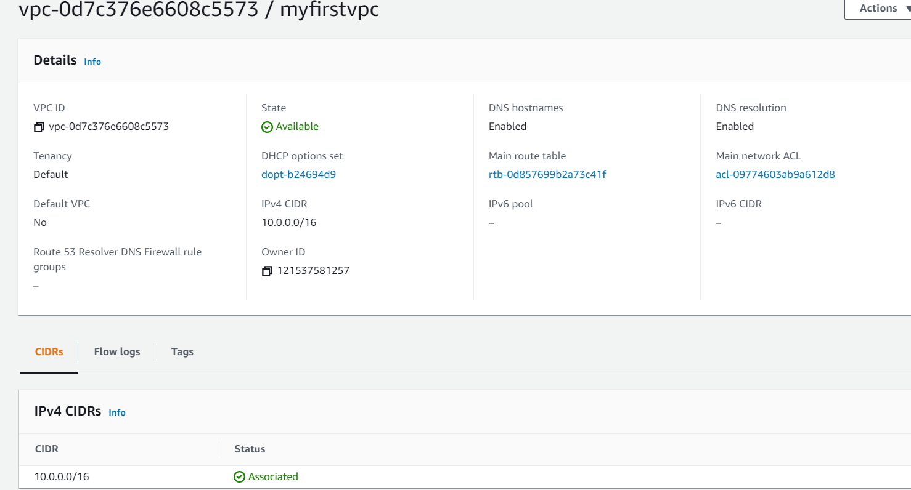

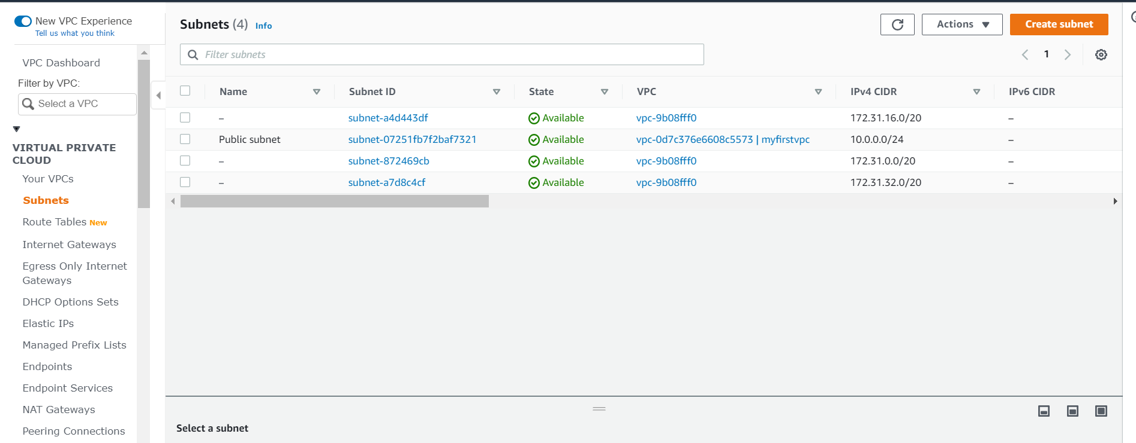

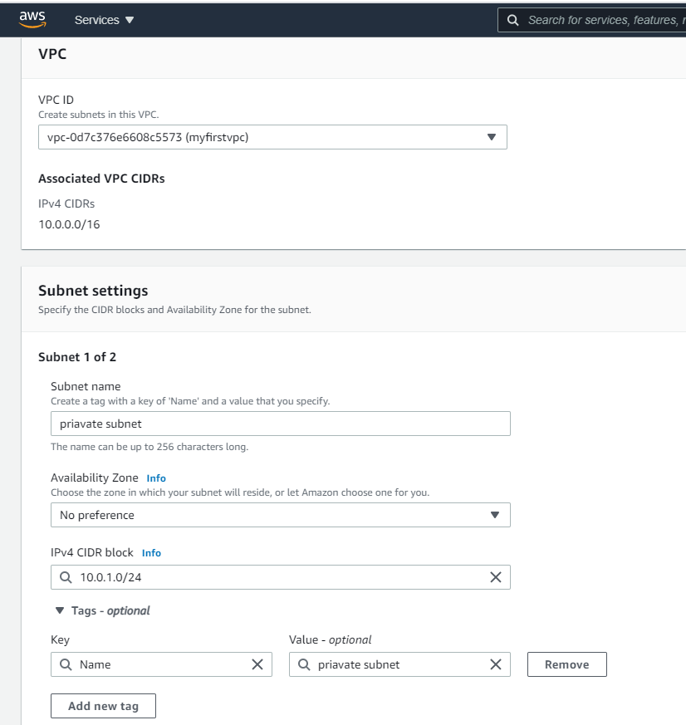

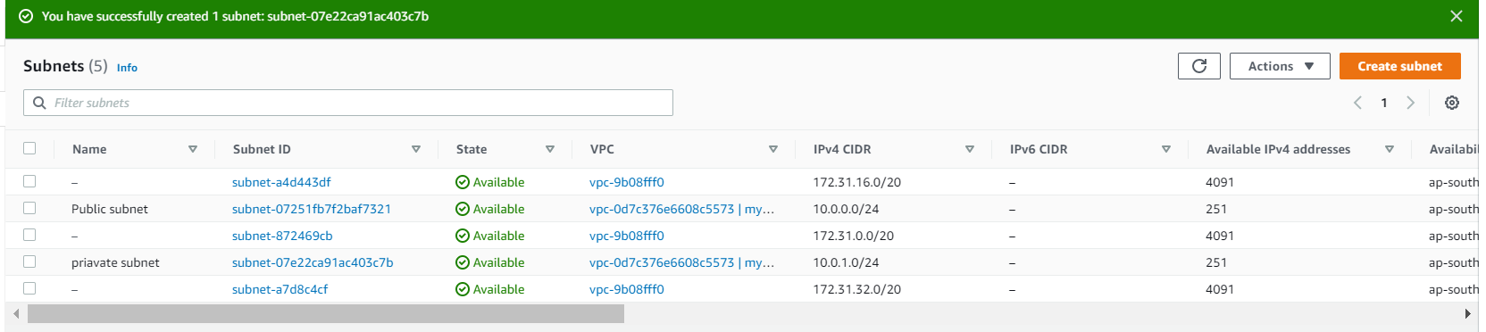

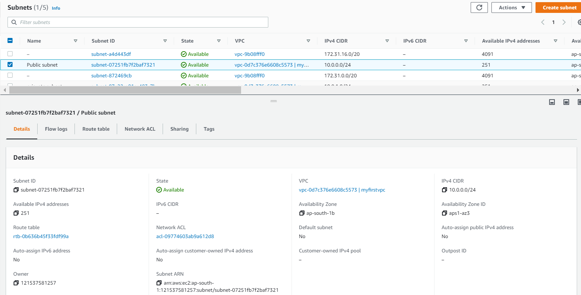

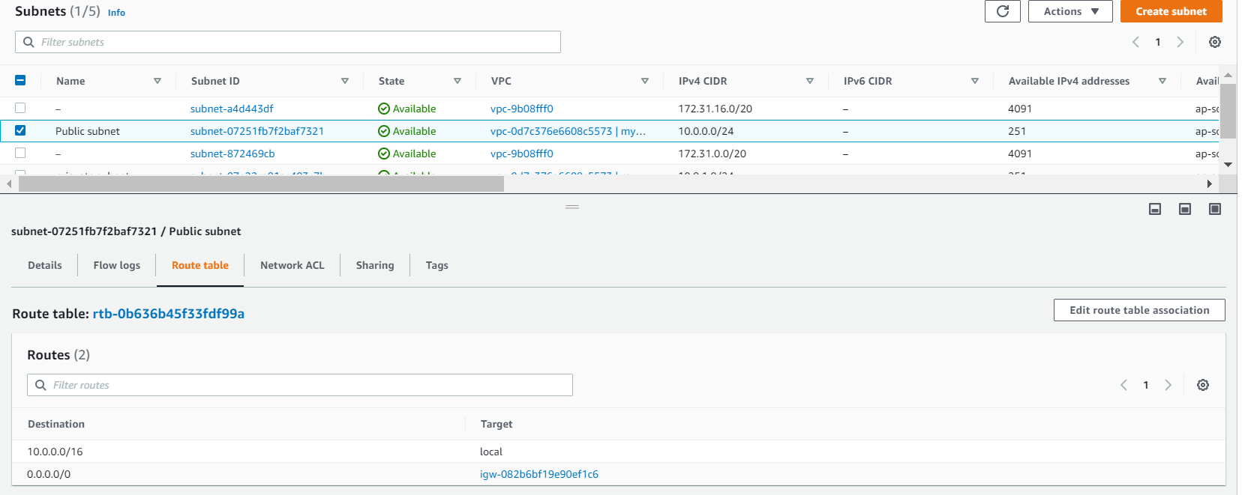

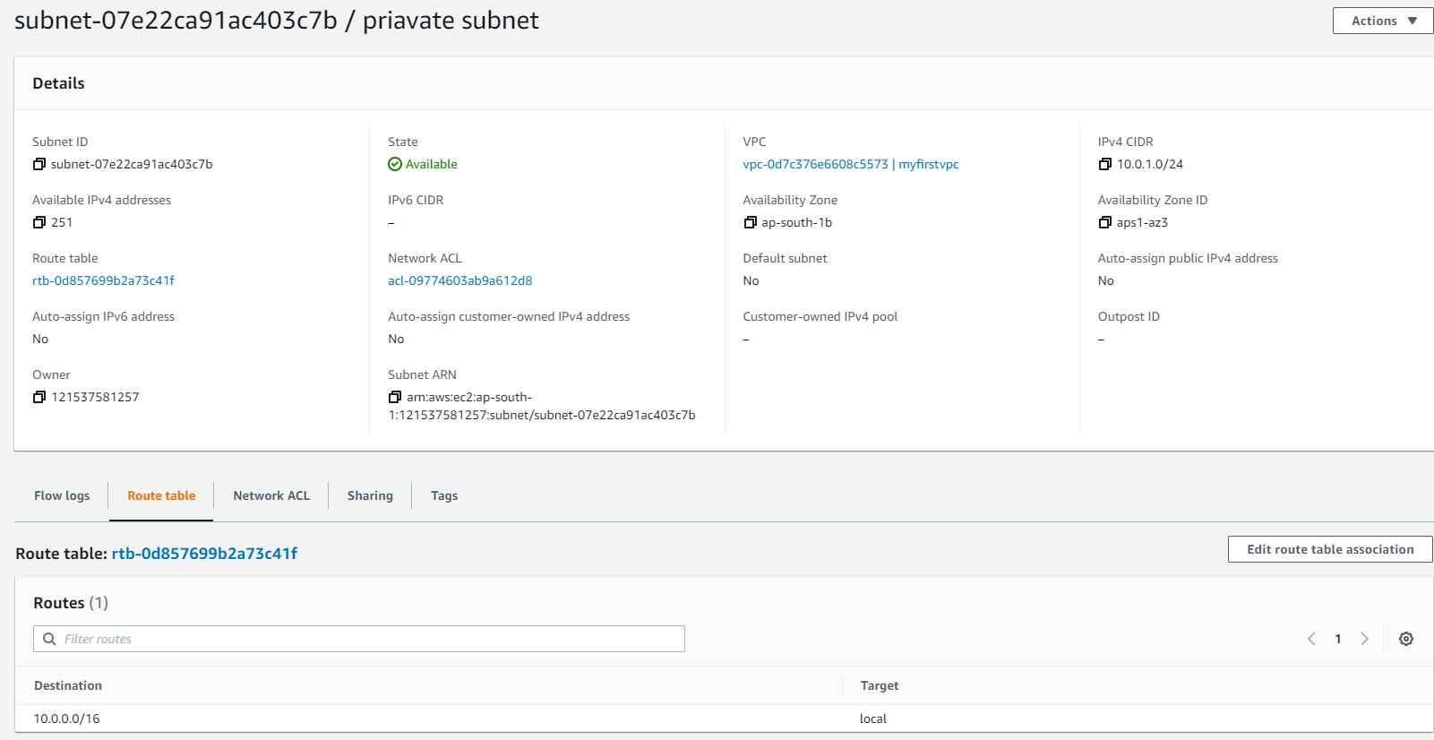

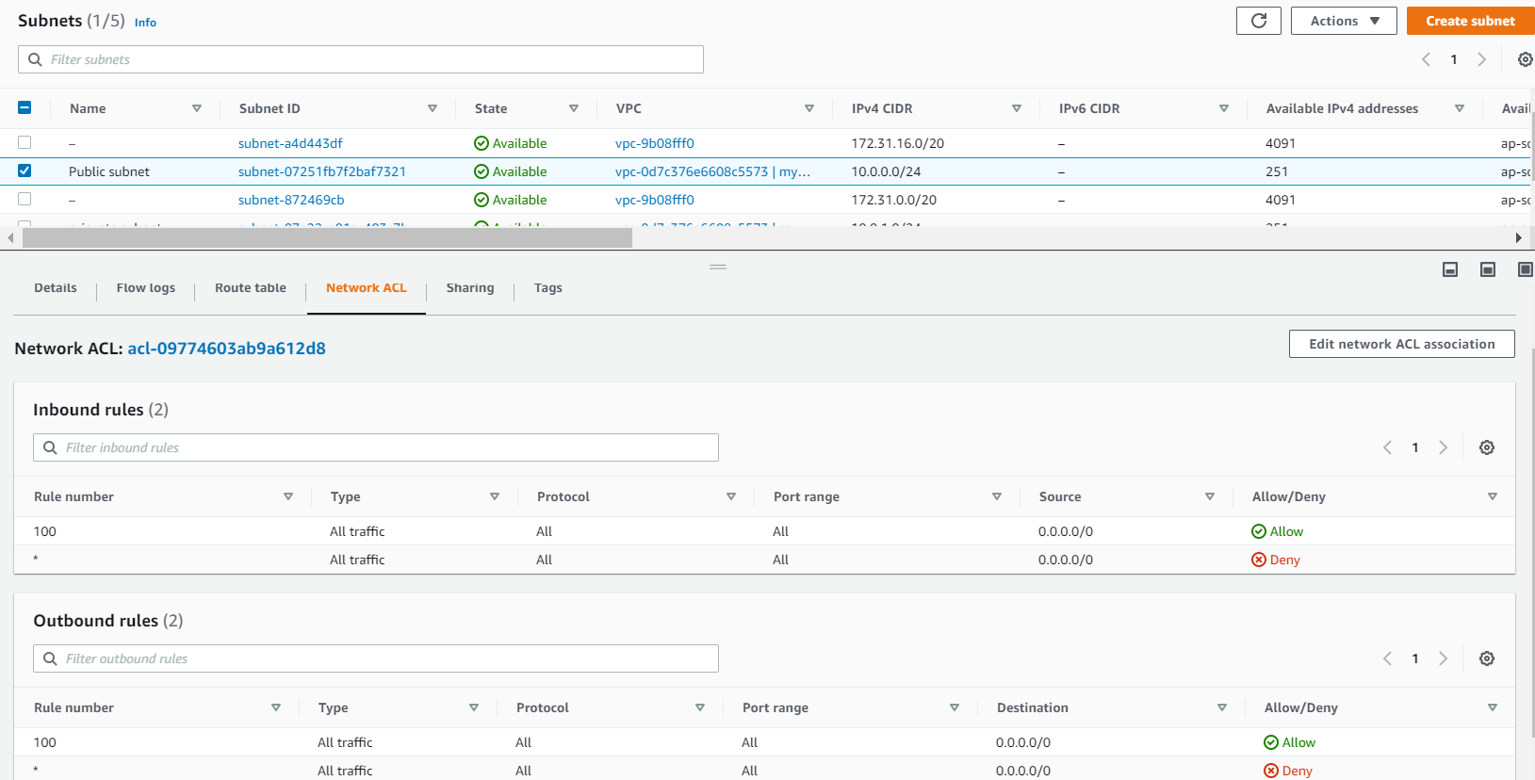

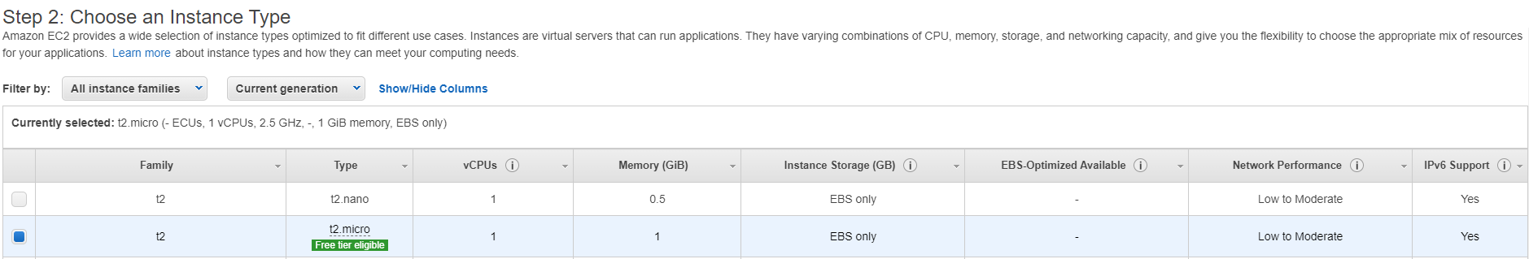

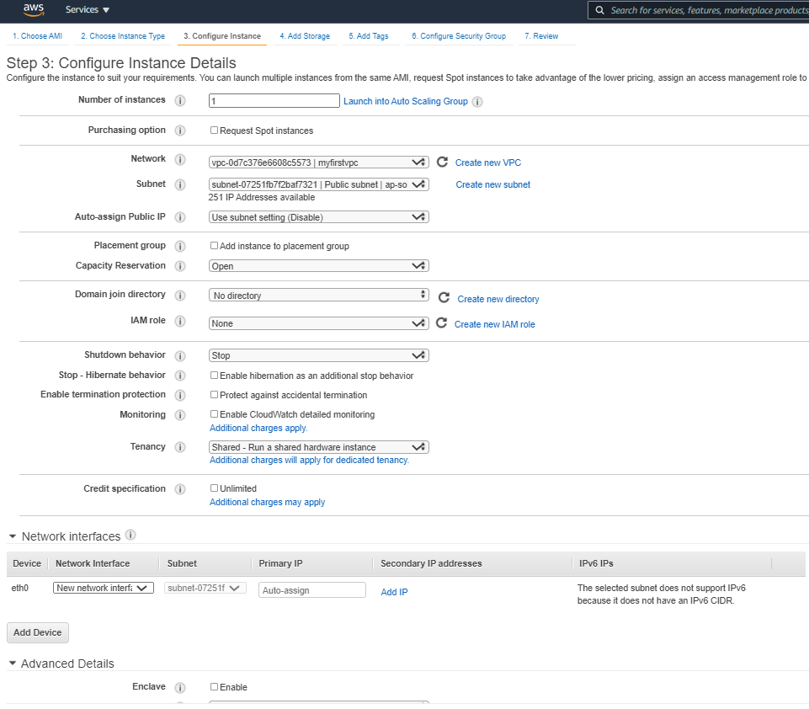

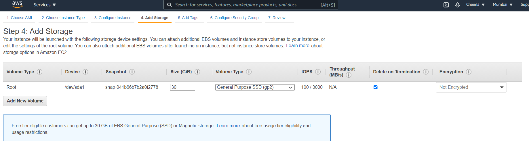

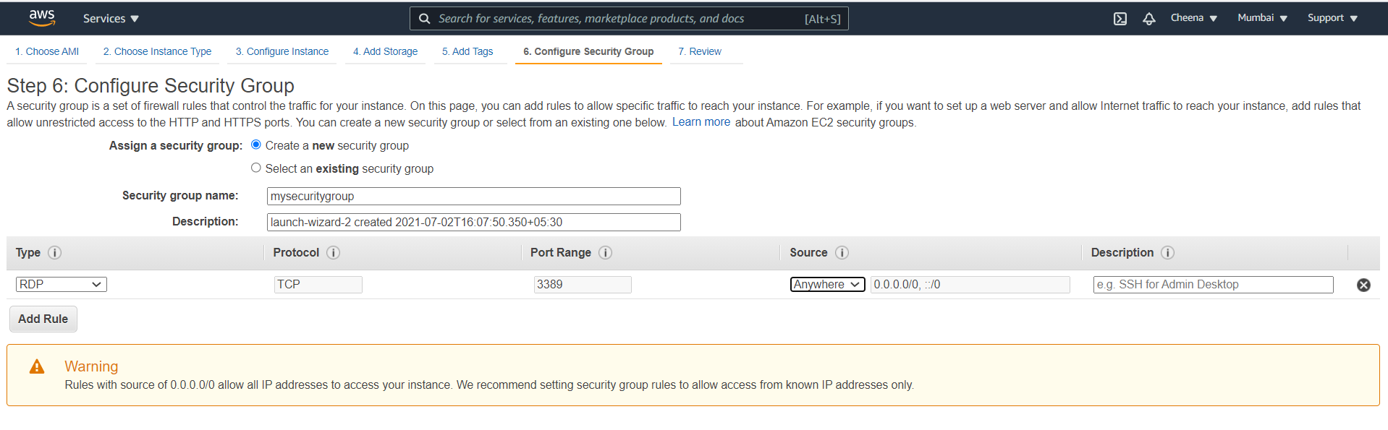

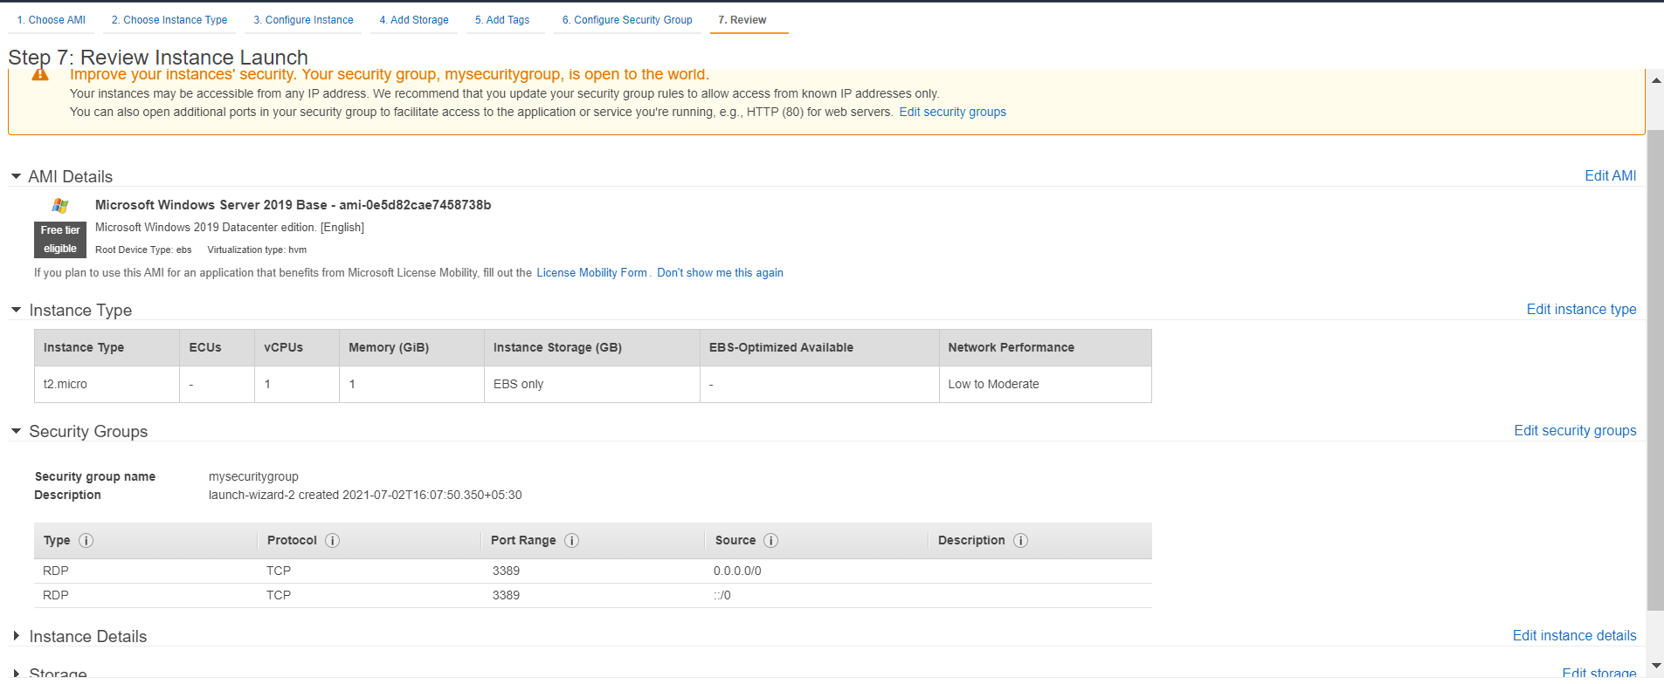

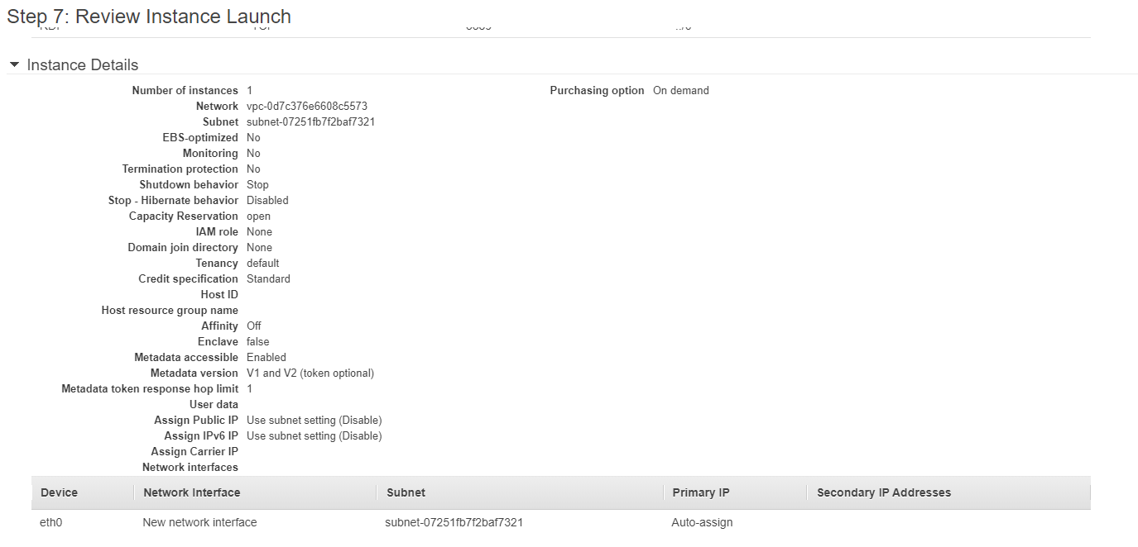

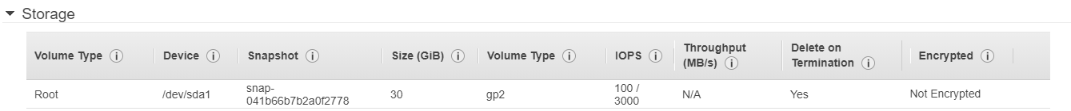

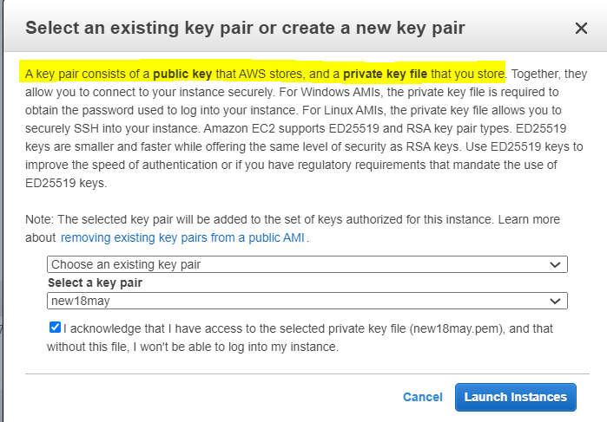

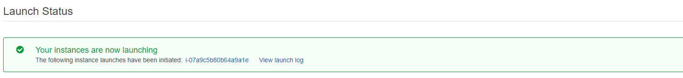

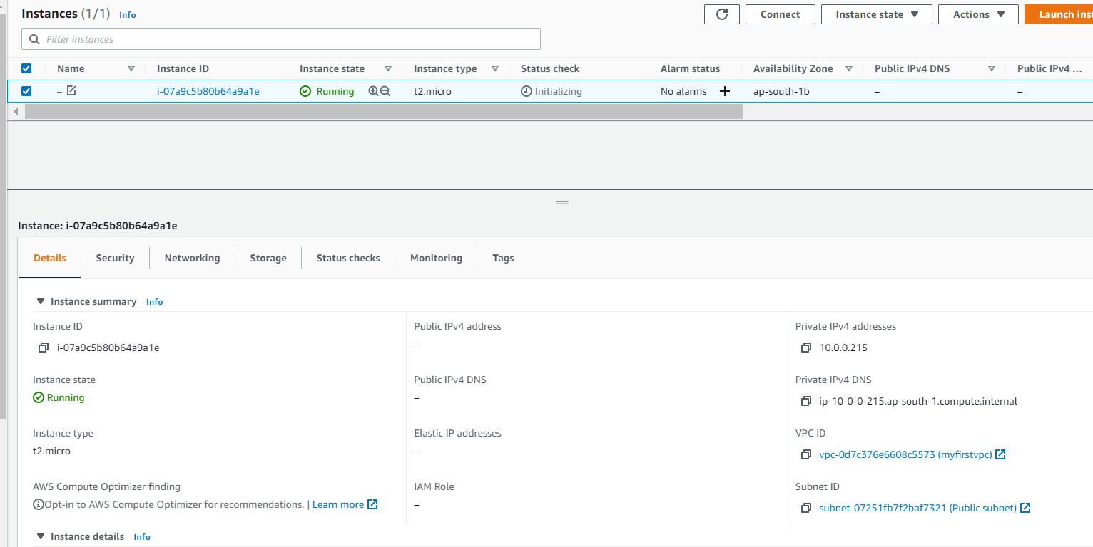

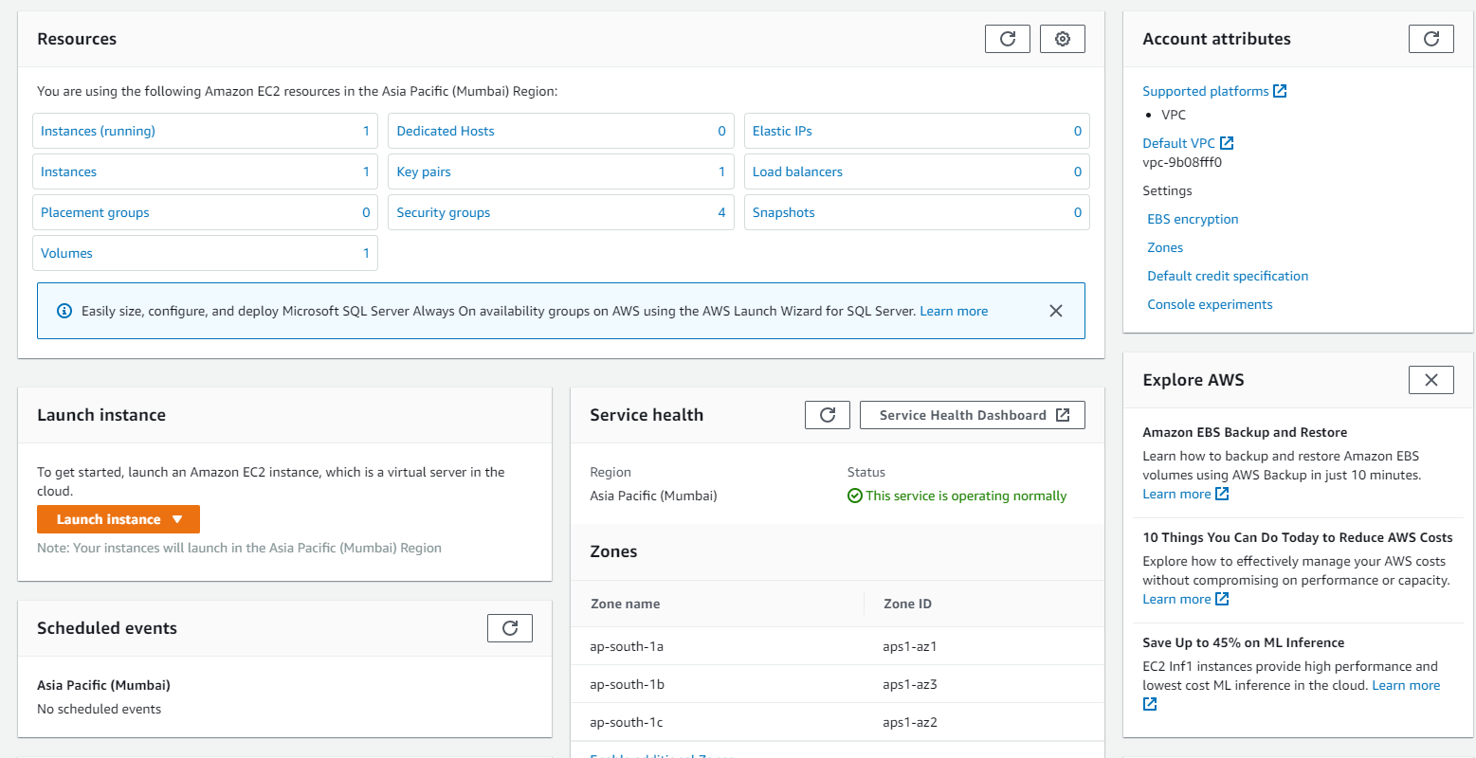

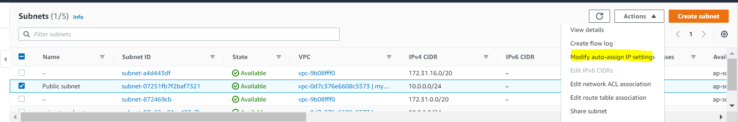

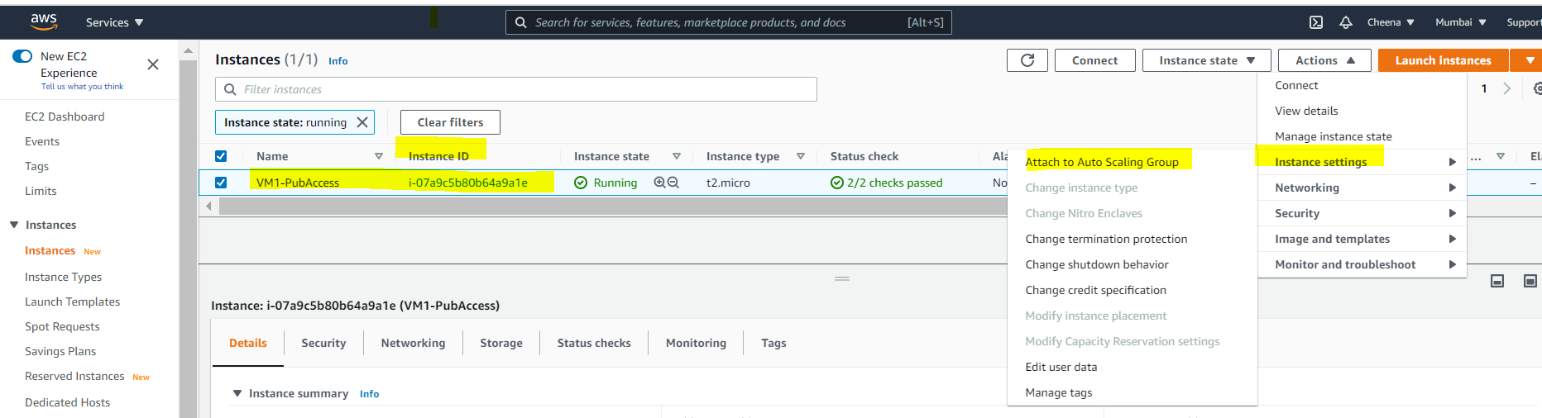

An **Availability Zone** is nominated when the **Subnet** is created. It is not possible to **change** the AZ on a **Subnet**. You should either create another **subnet**, or delete the **subnet** and recreate it in a different AZ

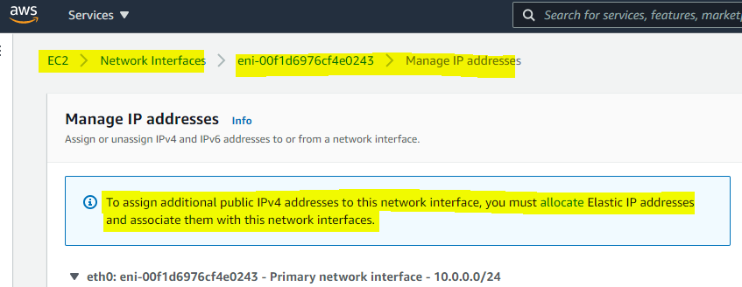

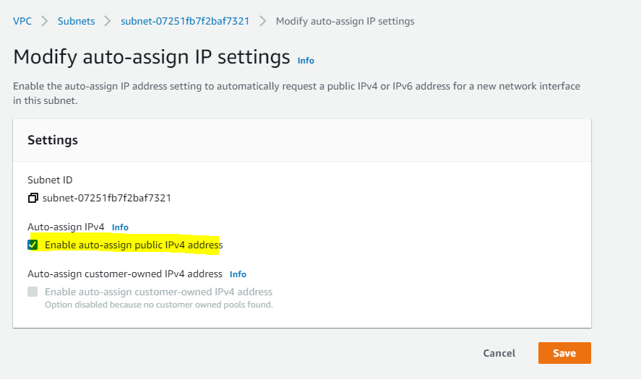

The only way I know is to select assign a public IP **before** launching the instance or having the subnet set up to auto assign public IPs which will do that only when you launch a new instance.

So to summarize: It is not possible to assign a public IP after launching that instance unless you

use EIPs.

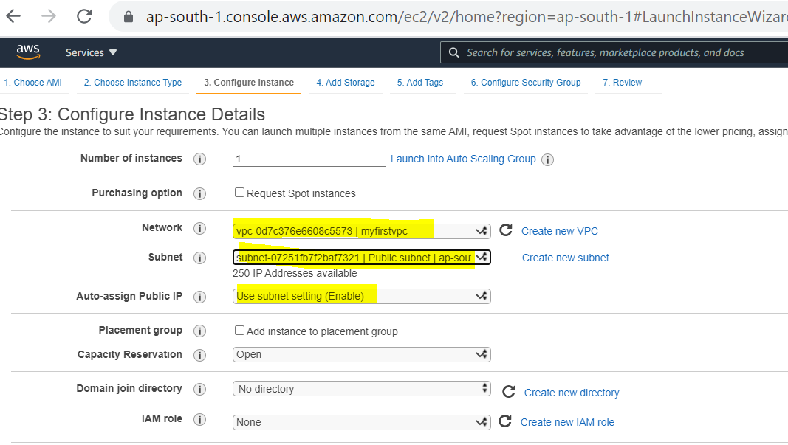

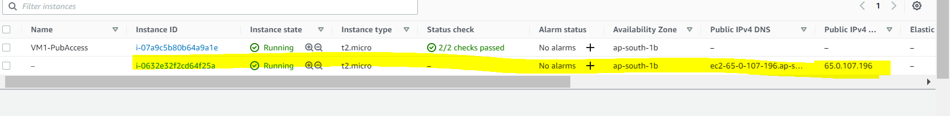

The instances **in the public subnet** can send outbound traffic directly to the internet, whereas the instances **in the private subnet** can't. Instead, the instances **in the private subnet** can access the internet by using a network address translation (NAT) gateway that resides **in the public subnet**.

**PUBLIC SUBNET** If a subnet's traffic is routed to an internet gateway, the subnet is known as a public subnet. **PRIVATE SUBNET** If a subnet doesn't have a route to the internet gateway, the subnet is known as a private subnet.

